WMR TIMELESS 458

Aust. Reg. No | USA16226527

Pedigree
Hyline Right Time 338
Leachman Right Time 338-5605
Leachman Erica 1201
W M R Dateline 210
Wmr Blackcap 521 Usa15183571
W M R Blackcap 043
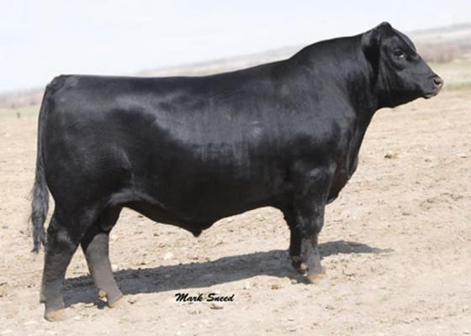
Bull ID: | 14AN398
Breeder/Source: | Accelerated Genetics, USA
HB Number: | USA16226527

TYPE
BREEED PLAN
TRAIT | EBV | Acc | % RK
CE Direct (CE Dir) | -5.9 | 76%
CE Daughter (CE Dtr) | -0.5 | 57%
Gestation Length (GL) | -6.9 | 98% | 10
Birth Weight (BW) | +7.20 | 98%
200D Weight | +61 | 96% | 1
400D Weight | +110 | 96% | 1
600D Weight | +139 | 94% | 1
Mature Cow Weight (MCW) | +120 | 85% | 5
Milk kg | +16 | 84%
Scrotal Size (SC) | +2.20 | 93% | 20
Days to Calving (DC) | -5 | 40% | 25
Carcase Weight (CW) | +90 | 81% | 1
Eye Muscle Area (EMA) | +7.20 | 82% | 10
Rib Fat (RIB) | +1.60 | 83% | 10
Rump Fat (RMP) | +1.40 | 79% | 15
Retail Beef Yield (RBY%) | +1.50 | 73% | 5
Intra-Muscular Fat (IMF%) | +0.80 | 75%
Net Feed Intake Post weaning (NFI-P) | +0.02 | 51%
Net Feed Intake Feedlot (NFI-F) | -0.11 | 53% | 15
Docility | +8 | 58%
Angus Breeding Index (ABI) | +$128 |  | 10
Domestic Index (DI) | +$121 |  | 5
Heavy Grain Index (HGI) | +$127 |  | 20
Heavy Grass Index (Grass I) | +$129 |  | 5

